Sponsorship Packages 2025 Sustainability Summit.

The planning committee welcomes external organisations who would like to be associated with the UON 2025 Sustainability Summit through sponsorship and partnership. The sponsorship packages on offer highlight how you can heighten your brand presence at what will be Northamptonshire’s leading sustainability event.

|  |  |  |  |
| --- | --- | --- | --- |
| **Package Inclusions** | **Gold Package (£5,000)** | **Silver Package (£3,000)** | **Bronze Package (£1,500)** |
| **Summit Tickets** | 20 Tickets | 10 Tickets | 5 Tickets |
| **Exhibition stand at the event** | ✓ | ✓ | ✓ |
| **Opportunity to display small**  **promotional materials at the event** | ✓ | ✓ | ✓ |
| **Mention in pre-event social media posts** | ✓ | ✓ | ✓ |
| **Verbal acknowledgment during the**  **event** | ✓ | ✓ | ✓ |
| **Logo on Summit webpages** | ✓ | ✓ | . |
| **Logo on the Summit brochure cover page** | ✓ | . | . |
| **Dedicated posts about the sponsor on the University’s social media pages** | ✓ | ✓ | . |
| **Sponsor acknowledgment in press**  **releases** | ✓ | ✓ | . |
| **Opportunity to speak or host a session/panel at the summit** | ✓ | . | . |
| **Logo and company bio in full Summit**  **brochure** | Two-page | One-page | Half -page |
| **Logo placement on event materials** | Prominent | Medium-sized | Small -sized |

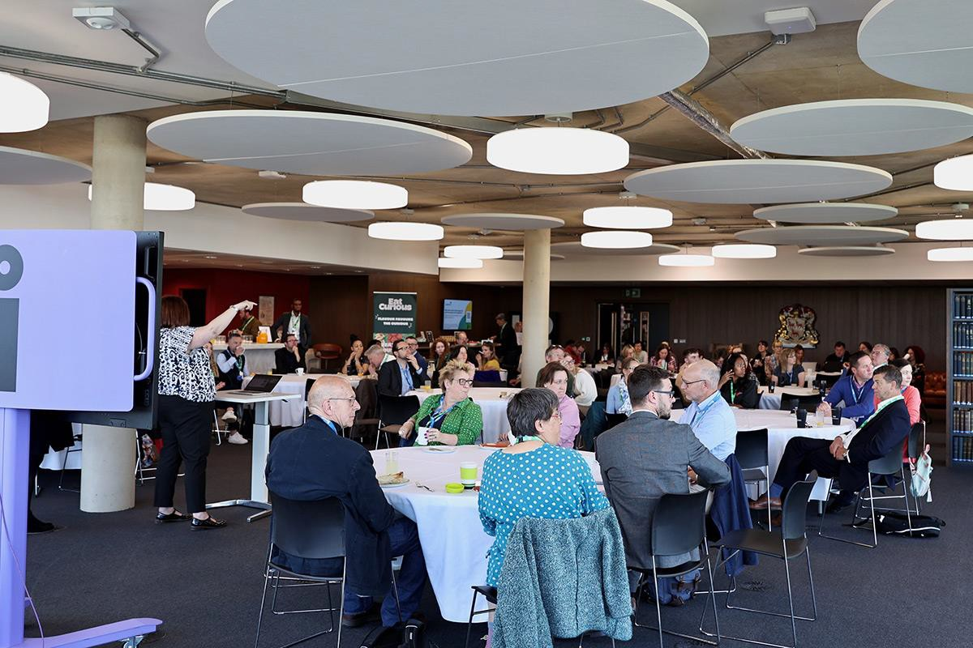

* 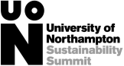**For sponsorship information, please contact:**

**Dr Chijioke Uba (**[**Chijioke.uba@northampton.ac.uk**](mailto:Chijioke.uba@northampton.ac.uk)**)**

**Dr. Oluwaseyi Omoloso (**[**seyi.omoloso2@northampton.ac.uk**](mailto:seyi.omoloso2@northampton.ac.uk)**)**